24 May 2024 postcard

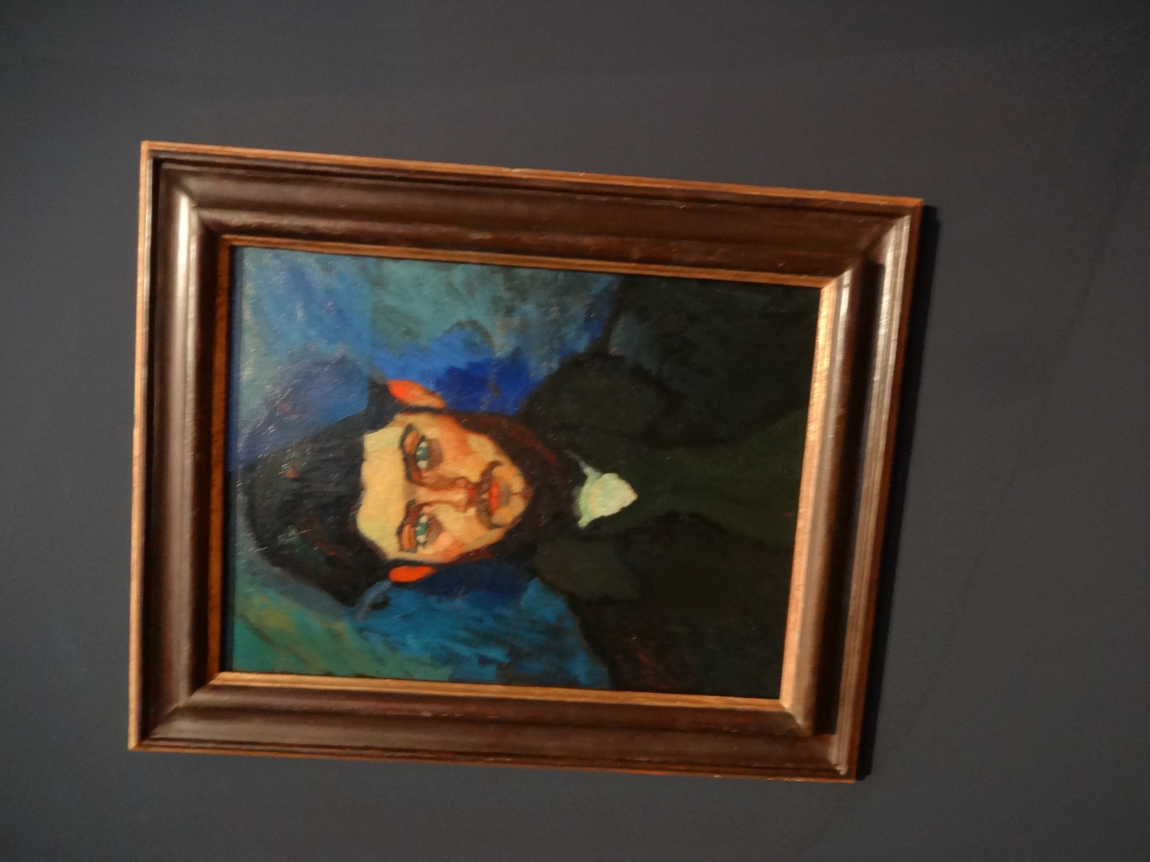An easier day today in Potsdam. After a leisurely breakfast, we visited the Hasso Plattner collection, in the reconstructed heart of the city. It's actually two collections in one. About half of the space is devoted to Amedeo Modigliani, an Italian painter and sculptor working mainly in France, who has a very distinctive style that, frankly, I can take or leave. I looked at it, and I learned a good deal about the artist and the evolution of his style, but I find that I didn't even get a good shot of one of his characteristic works. The one shown here is very early and highly uncharacteristic (no almond eyes, no vertical elongation), but I liked it best of the lot. It's a portrait of the artist's friend, Maurice Drouard.

The rest of the collection, though, was terrific! It was solidly impressionist, and included myriad works by artists we're very familiar with (Monet, Renoir, Sisley, Morisot, Pissarro, Signac), but that we hadn't seen before.

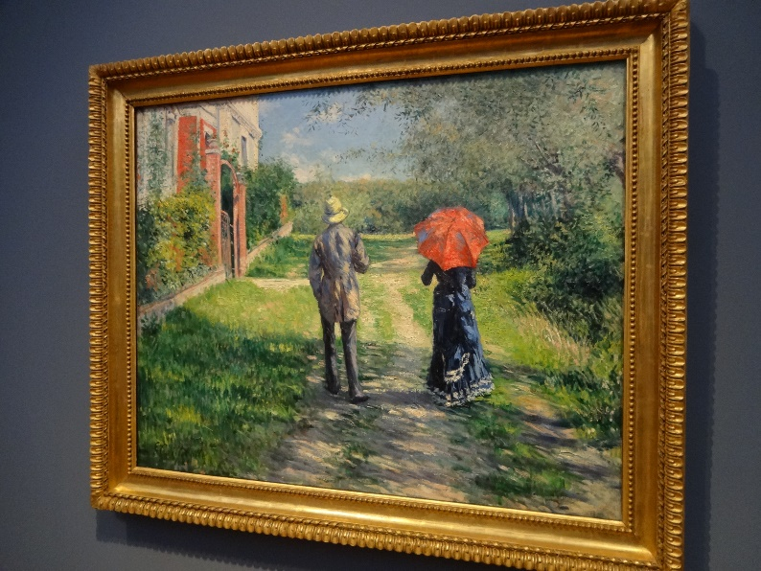In particular, it held a treasure-trove of the works of Gustave Caillebotte. Caillebotte was good friends with Renoir and the others, and definitely part of their artistic group, but he was independently wealthy, so he didn't particularly care whether he sold his work. He subsidized his friends by buying and collecting their works (later leaving them to the French nation), but his own works mostly stayed in his family for decades.

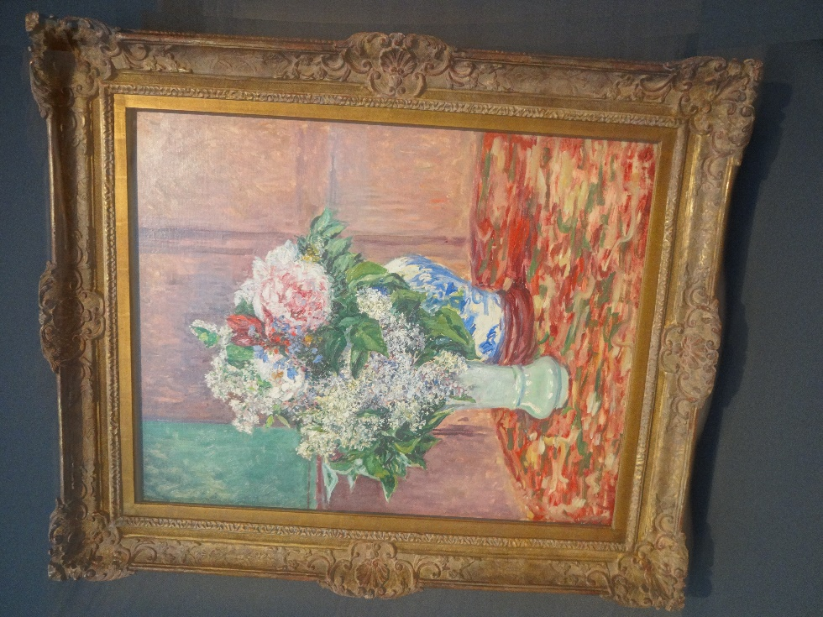

Somehow this collection had acquired quite a number of them, including the two shown here (*Couple on a Path* and *Lilacs and Peonies in a Vase*). It left me with a whole new appreciation of him.

Before, I had seen a couple of his works but I knew him mostly as the guy in a straw hat and white t-shirt sitting backwards on a chair in the lower right foreground of *Luncheon of the Boating Party.*

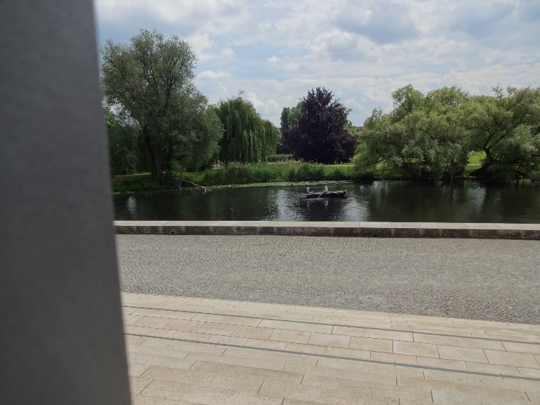We had quiche for lunch in the museum's café, overlooking this lovely waterway, where a great gray heron hung around for most of the time.

Then we just headed back to the hotel to rest up for dinner.

We had reservations at Die Fliegenden Hollander (The Flying Dutchman), a few blocks away.

*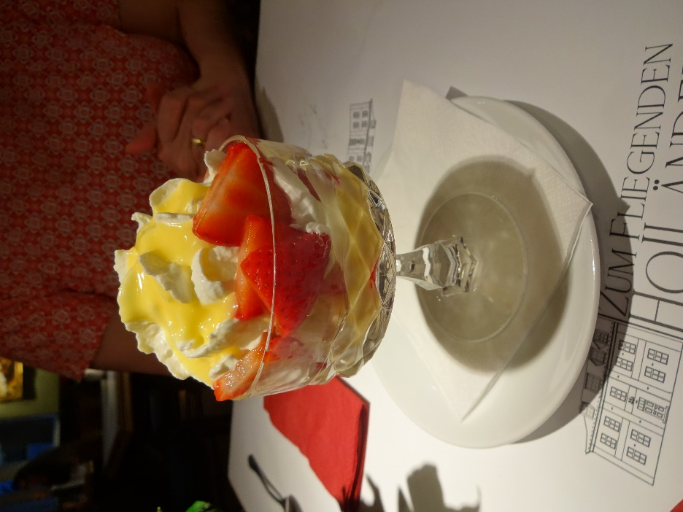*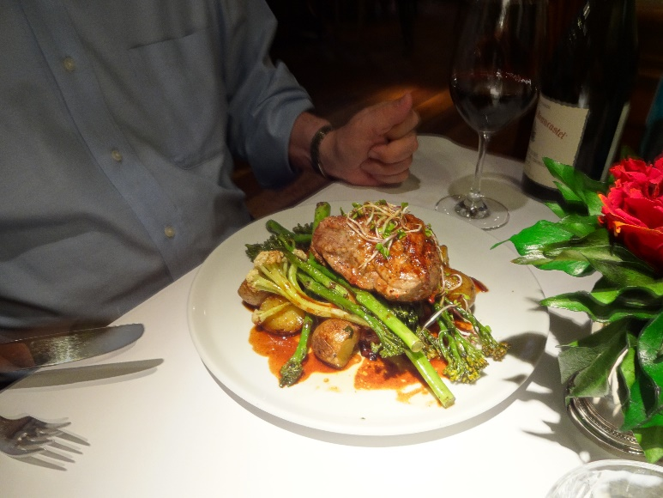The most photogenic entrée was David's roast veal filet, but the dessert Gritta and I shared (vanilla ice cream with strawberries, whipped cream, and egg liqueur) was pretty handsome too.